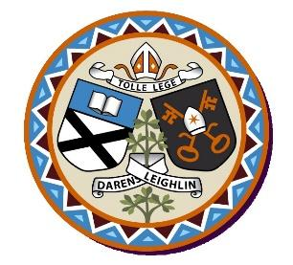
Derrylamogue National School
Annual Admission Notice
in respect of admissions to the 2022/2023 school year

Admission Policy and Application Form
A copy of the school’s Admission Policy and the Application Form for Admission for the 2022/2023 is available as follows: –
To download at: www.derrylamoguens.ie
On request: By emailing info@derrylamoguens.com
or writing to Derrylamogue NS, Rosenallis, Co. Laois

Part 1 - Admissions to the 2022/2023school year

Application and Decision Dates for admission to 2022/2023
The following are the dates applicable for admission to Junior Infants

The school will commence accepting applications for admission on | 13-01-2022
The school shall cease accepting applications for admission on | 27/01/2022
The date by which applicants will be notified of the decision on their application is | 17/02/2022
The period within which applicants must confirm acceptance of an offer of admission is | 10/03/2022.

Note: the school will consider and issue decisions on late applications in accordance with the school’s Admission Policy.

*Failure to accept an offer within the prescribed period above may result in the offer being withdrawn

Number of Places being made Available in 2022/2023

The number of places being made available in junior infants | 15

