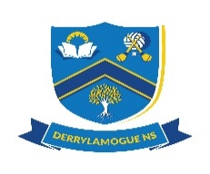
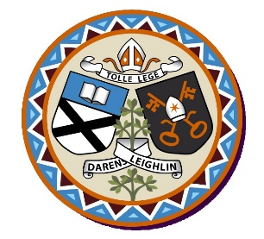
Derrylamogue NS
Annual Admission Notice
in respect of admissions to the 2024/2025 school year
Admission Policy and Application Form
A copy of the school’s Admission Policy and the Application Form for Admission for the 2024 – 2025 is available as follows: –
To download at: www.derrylamoguens.ie
On request: By emailing info@derrylamoguens.com
or writing to Derrylamogue NS, Rosenallis, Co. Laois. R32YD81
Part 1 - Admissions to the 2024/2025 school year
Application and Decision Dates for admission to 2024/2025
The following are the dates applicable for admission to Junior Infants

The school will commence accepting applications for admission on | 08/01/2024
The school shall cease accepting applications for admission on | 22/01/2024
The date by which applicants will be notified of the decision on their application is | 12/02/2024
The period within which applicants must confirm acceptance of an offer of admission is | 04/03/2024

The following are the dates applicable for admission to classes other than Junior Infants

The school will commence accepting applications for admission on | 08/01/2024
The school shall cease accepting applications for admission on | 22/01/2024
The date by which applicants will be notified of the decision on their application is | 12/02/2024
The period within which applicants must confirm acceptance of an offer of admission is | 04/03/2024

Note: The school will consider and issue decisions on late applications in accordance with the school’s Admission Policy.
*Failure to accept an offer within the prescribed period above may result in the offer being withdrawn

Special Class Application and Decision Dates for admission to 2024/2025
The following are the dates applicable for admission to the school’s Special Class which caters for children with ASD

The school will commence accepting applications for admission to the special class on | 08/01/2024
The school shall cease accepting applications for admission to the special class on | 22/01/2024
The date by which applicants will be notified of the decision on their application for admission to the special class is | 12/02/2024
The period within which applicants must confirm acceptance of an offer of admission is | 04/03/2024

Note: Failure to accept an offer within the prescribed period above may result in the offer being withdrawn.
The School will consider and issue decisions on late applications in accordance with the school’s Admission Policy.

Number of Places being made Available in 2024/2025
The number of places being made available in Junior Infants | 13
The number of places being made available in the special class* catering for children with ASD | 0

